Chapter 6 Review

1. Sketch a Maxwell Boltzmann Curve. Show the curve for a sample at 345K. Label it A. Show the curve for the same sample at 490K. Label it B.

2. True or False: The relationship between the average kinetic energy of the particles in a sample is indirectly proportional to the temperature.

3. Given w = 0, an endothermic reaction has the following.

A) +ΔH and -ΔE

B) - ΔH and +ΔE

C) + ΔH and +ΔE

D) - ΔH and -ΔE

4. Calculate the E for a system that has 13J of work done on it and releases 33J of heat.

5. Define the ∆heat of formation. Why are the ∆heat of formation for elements zero?

6. The internal energy can be increased by __________.

(a) transferring heat from the surroundings to the system

(b) transferring heat from the system to the surroundings

(c) doing work on the system

A) a only

B) b only

C) c only

D) a and c

E) b and c

7. ) Which of the following processes is endothermic?

A) the freezing of water

B) the combustion of butane

C) a hot cup of coffee (system) cools on a countertop

D) the chemical reaction in a "hot pack" often used to treat sore muscles

E) the vaporization of rubbing alcohol

8. The value of ΔE for a system that performs 111 kJ of work on its surroundings and gains 89 kJ of heat is __________ kJ.

A) -111

B) -200

C) 200

D) -22

E) 22

9. An 8.29 g sample of calcium carbonate [CaCO3 (s)] absorbs 50.3 J of heat, upon which the temperature of the sample increases from 21.1 °C to 28.5 °C. What is the specific heat of calcium carbonate?

A) .63

B) .82

C) 1.1

D) 2.2

E) 4.2

10. In the reaction below, ΔHf° is zero for __________.

Ni (s) + 2CO (g) + 2PF3 (g) → Ni(CO)2 (PF3)2 (l)

A) Ni (s)

B) CO (g)

C) PF3 (g)

D) Ni(CO)2(PF3)2 (l)

E) both CO (g) and PF3 (g)

11. Given the data in the table below, ΔH°rxn for the reaction

3NO2 (g) + H2O (l) → 2HNO3 (aq) + NO (g)

is __________ kJ.

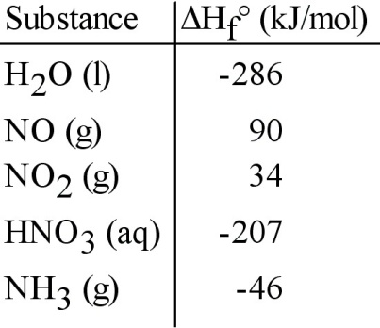

A) 64

B) 140

C) -140

D) -508

E) -64

12. In the presence of excess oxygen, methane gas burns in a constant-pressure system to yield carbon dioxide and water:

CH4 (g) + 2O2 (g) → CO2 (g) + 2H2O (l) △H = -890.0 kJ

Calculate the value of q (kJ) in this exothermic reaction when 1.70 g of methane is combusted at constant pressure.

A) -94.6

B) 0.0306

C) -0.0106

D) 32.7

E) -9.46 × 104

13. Which one of the following conditions would always result in an increase in the internal energy of a system?

A) The system loses heat and does work on the surroundings.

B) The system gains heat and has work done on it by the surroundings.

C) The system loses heat and has work done on it by the surroundings.

D) The system gains heat and does work on the surroundings.

E) None of the above is correct.

14. Energy that is associated with the temperature of an object and is dependent of its mass is called

A) kinetic energy

B) thermal energy

C) potential energy

D) chemical energy

15. How much energy is evolved during the formation of 197 g of Fe, according to the reaction below?

Fe2O3(s) + 2 Al(s) → Al2O3(s) + 2 Fe(s) ΔH°rxn = -852 kJ

A) 1.52 x 103 kJ

B) 3.02 x 103 kJ

C) 8.40 x 103 kJ

D) 964 kJ

E) 482 kJ